Strategic Improvement Priorities Plan over 3-year cycle Timescale: 2023-2026

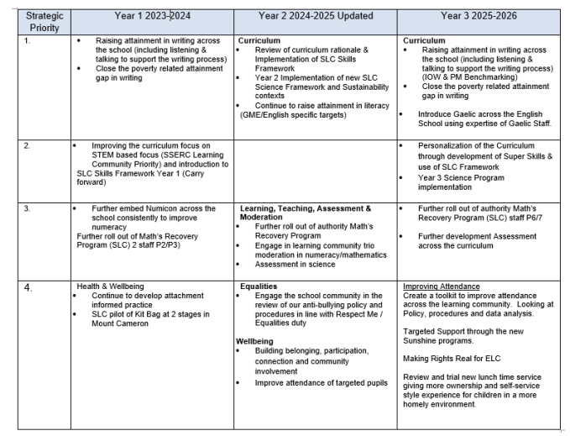
Context of school
Mount Cameron is a non-denominational Primary and Nursery school situated in the St Leonards South area of East Kilbride. The school opened in 1970 and the new school building was opened in 2017. Our school is a unique establishment within the South Lanarkshire Council school estate as it is the only school offering a primary school Gaelic Medium Education in the authority. We currently have four Gaelic classes and 7 English classes. The Gaelic Department represents children from across South Lanarkshire Council. We offer an Early Years Provision of 1140 hours within two nursery classes: one for English and one for Gaelic Medium Education. In addition to our own nursery classes, Mounties Private Partnership Nursery Class is hosted within our school building, and we welcome and celebrate positive relationships across our settings. Many Mounties children continue onto Mount Cameron. The nursery classes are included in life and work of the school and there are many opportunities to work together. There is a mix of private, rented and emergency housing needs in the area around the school. The average Social Index of Multiple Deprivation (SIMD) for St. Leonard’s South is decile 5.
Our Learning Community
Mount Cameron Primary School & Nursery Classes are part of the Calderglen Learning Community, and our feeder secondary school is Calderglen High. The school celebrates positive relationships with Calderglen and its’ feeder primary schools. Our school has a strong reputation within the local and wider community.
Our Accommodation
Our accommodation is bright and attractive, and we take pride in our school. The accommodation includes 11 classrooms, three nursery rooms, a multimedia & school library room, a CUSTTAD (combined use of sand trays, talk and draw therapy), a wellbeing/playroom (The Sunshine Room), a large well equipped gym hall with stage, a range of offices, a canteen, staffroom and storage rooms. Outdoors, we have extensive grounds which include a mix of tarmac and grassy areas, a shinty pitch and trim-trail equipment. There is an internal outdoor courtyard area which has been as an outdoor classroom. The nursery classes each have their own well equipped and exciting outdoor learning play spaces. This includes a summer house.
Vision, Values and Aims
Our school values are embedded in the life and work of the school. The involvement of all children, staff, families and partners have been imperative in shaping the direction of the school and we highly value collaboration and consultation with parents.

The nursery children have developed their own super-hero characters in partnership with Calderglen High School. This is to help the children to relate further to our school values and to make them more meaningful to our youngest children

Our Pupil Aims
What matters most to our children?
- To be happy and joyful in school
- To be loving and kind to themselves and others
- To be healthy (emotionally, socially, and physically)
- To be responsible and persistent in learning and throughout their school journey
- To be respectful and inclusive

Our Staff Aims
What we need to do as professionals to ensure we deliver this for our children?
- We will be happy and joyful in our interactions with learners
- We will model kindness in our own behaviours, be patient and caring with all our children
- We will be passionate and committed to our profession
- We will be trusted and collaborative in our practice as we move forward together
- We will be inclusive in our thinking and actions

Performance Data - Achievement of Curriculum for Excellence Levels (official data 2023/24)
File path: Data Portal > Primary > Attainment Tools > SSR (Primary) 1.106 (Jun 25).xlsx
Performance Data (Literacy and Numeracy Stage147) - Excellence Over Time Charts 2016/17-2023/24
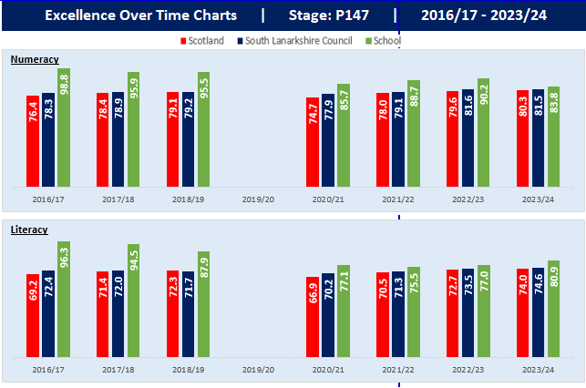
Performance Data (Literacy and Numeracy P 147) - Equity (Local) Over Time Charts
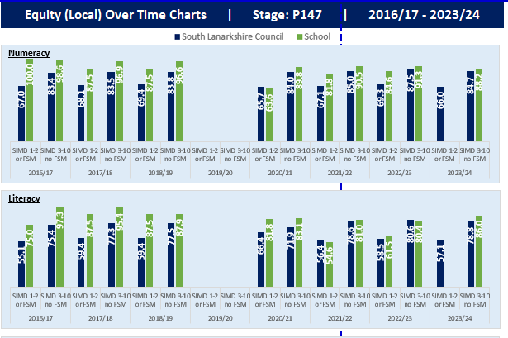
Improvement Planning and Standards and Quality Reporting for 2025/2026
Priority 1 Improving Our Writing
NIF Priority (select from drop down menus)  Improvement in achievement, particularly in literacy and numeracy.  NIF Outcome  Staff and SLT driving excellent LTA skills, esp. for learners with ASN  Closing the attainment and achievement gap | SLC Priority (select from drop down menus)  Provide a rich and stimulating curriculum that helps raise standards in literacy and numeracy  Support children and young people to develop their skills for learning, life and work | SLC Stretch Aims  ACEL Primary – literacy – P1, P4 & P7 combined  Choose an item. | HGIOS?4 QIs (select from drop down menus)  2.3 Learning, teaching and assessment  3.2 Raising attainment and achievement  Choose an item.  HGIOELC QIs (select from drop down menus)  Choose an item.  Choose an item.  Choose an item.
Rationale for strategic priority | Outcome (Intended impact) | Operational activity | Measures |  | School Lead
Writing attainment data highlights the need to focus on continuing to improve writing levels for learners through high quality learning, teaching and assessment approaches developed through the professional learning materials of the IOW programme. Mount Cameron has not reached pre covid attainment in Literacy.  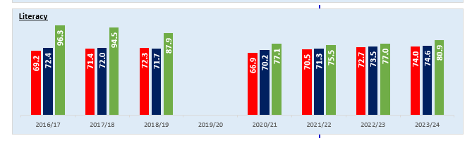 | By October 2025, a rigorous self -evaluation process will result in a clear focus for our writing improvement October 2025- May 2026. | August-Oct 2025  - IOW introductory CLPL sessions on the IOW programme and short webinar CLPL sessions on the 15 writing elements.  - Staff complete pre- IOW Professional Learning confidence survey.  - Pupil work audit  - Learner writing motivation surveys  - Teaching staff and SLT to complete Fact, Story, Action for writing for each | Writing attainment data highlights the need to focus on continuing to improve writing levels for learners through high quality learning, teaching and assessment approaches developed through the professional learning materials of the IOW programme.  (Schools should add context specific data) |  | By October 2025, a rigorous self -evaluation process will result in a clear focus for our writing improvement October 2025- May 2026.
Progress and Impact |  |  |  | Next Step(s) and rationale to inform SIP for 2026/2027 or establishment maintenance agenda
Improvement Planning and Standards and Quality Reporting for 2025/2026
Priority 2 Explicit Teaching of Writing though the embedding of Whole School Approach (PM Benchmarking)
NIF Priority (select from drop down menus)  Choose an item.  NIF Outcome  Choose an item.  Choose an item. | SLC Priority (select from drop down menus)  Choose an item.  Choose an item. | SLC Stretch Aims  Choose an item.  Choose an item. | HGIOS?4 QIs (select from drop down menus)  Choose an item.  Choose an item.  Choose an item.  HGIOELC QIs (select from drop down menus)  Choose an item.  Choose an item.  Choose an item.
Rationale for strategic priority | Outcome (Intended impact) | Operational activity | Measures |  | School Lead
Mount Cameron 24/25 have looked at arrange of writing pedagogy and resources and have worked with Hunter Ps on joint in-service training exploring the explicit teaching of writing. As a result, staff have focused trialling elements of this tentatively through the use of PM Writing Approach.  Staff voice opted for the purchase and implementation of this to ensure consistency of approaches to writing.  Through rigorous self-evaluation of last sessions Improvement Priority in Writing, staff reported that the school requires to continue to develop this at all levels as consistencies remain. | - By the end of June 2026, all Teaching Staff will be familiar with, and have regular opportunity to engage in PM Writing approach (Explicitly teaching writing) in their class. This will ensure a consistent approach to teaching Writing across the school.  - A consistent approach to teaching Writing (Text Types) will be agreed at the start of session 2025-26 that will ensure all classes are working on the same learning experiences (CfE level dependent).  - By September all staff will have a raised awareness of the key features of the model of explicitly teaching writing based on the describing bubble. The ‘describing bubble’ will be accessible to all pupils on classroom wall display and regularly referenced.  - By December 2025, staff will become familiar with and report confidence in using the new PM Writing resource.  - By the end of May 2025, Staff will be able to link PM Writing pedagogy to CfE, including planning, assessment, tracking and reporting pupil progress.  - Moderation Writing activities with identified Calderglen Learning Community Primaryschools & Peer Review Schools will support development and understanding of this through professional dialogue and peer visits. This will support in the moderation of pupil progress in Writing and enhance teacher professional judgement.  - By June 2025, there will be a clear and consistent approach to teaching Writing across all stages in Mount Cameron Primary School. | - Teaching staff will engage In-Service training sessions based on the Stephen Graham input already delivered.  - Teaching staff will agree the set order to teaching ‘Text Types’ across the session. (Description, Information Report, Explanation, Exposition and Narrative).  - Through engagement in PM Writing CLPL to raise awareness of what it means to be a ‘Balanced Writer’ and how explicitly teaching writing helps to achieve this.  - All staff will have the opportunity during November 2025 In-Service Day to engage in purposeful training of the PM Writing resource. This will include the physical books as well as the online platform.  - All staff will have the opportunity during November 2024 In-Service Day to engage in purposeful CLPL training of PM Writing approach to link to CfE. This will include planning and assessment.  - Teaching staff in Mount Cameron, Blacklaw and Jackton Primary schools will engage in a writing moderation CAT & in-service day session sessions across. With peer visits from our peer review schools also focusing on the delivery of writing pedagogy 2025-26 with a view to raise attainment and develop teacher professional judgements.  - Through robust self-evaluation, updated planning materials will be in place across all stages. | - Learning, Teaching and Tracking consultations and Classroom Observations.  - Staff CLPL evaluations, Professional dialogue, Learning, Teaching and Tracking consultations.  - Follow up professional dialogue. Implementation at class level.  - Staff CLPL evaluations, Professional Dialogue, engagement in using the new resource. Training will be led by SLT.  - Staff training will be led by SLT.  - Moderation activities, Tracking meeting dialogue, Professional dialogue.  Learning, Teaching and planning materials. Classroom observations. |  | HT and All Staff  HT and All Staff  All staff  All staff  All staff  All staff  SLT
Literacy (Gaelic School)  Progress has been made to develop a whole school programme regarding Gàidhlig talking and listening. Education Scotland recently updated its Advice for Gaelic Education and there is a need to ensure that the advice in this document is embedded in the GME practice for total immersion and immersion of Gàidhlig. In P5-7 there is reluctance from children to speak with adults and peers in Gàidhlig and to ensure children’s language fluency is progressing in line with national benchmarks children and parents need to be engaged as part of the development. | - All staff will be practising total immersion and immersion in their classrooms and Gàidhlig will consistently be the language of learning and teaching.  - Staff will use benchmarking resources such as HGIOS to audit the usage of Gaidhlig language in the classroom and identify best practice and areas for development. An overall understanding of usage of Gàidhlig language across the department will emerge.  - Staff will continue to gain confidence in using Frèam Cànan to plan, assess and evaluate through moderation with staff from other settings.  - Staff will have a bank of moderated resources that have been evaluated against national benchmarks.  - Staff have access to a progressive Gàidhlig Phonological and Phonemic Awareness Early Years resource.  - Staff have access to a progressive Gàidhlig spelling resource for First and Second level.  - Parents are more engaged and informed about Gaelic Medium Education in Mount Cameron Primary  - Children in Gaelic classes are more willing to use Gàidhlig in learning and in play. | - Revisit Education Scotland Advice on Gaelic Education and update Gaelic language total immersion and immersion practice outlined in school policy. Update Literacy and Gàidhlig position statement (policy) to reflect Advice on Gaelic Education and to include current practice in classes and reflect school curriculum rationale  - Audit classroom practice with regards to total immersion and immersion practice to ensure Gaidhlig is the language of the classroom and identify approaches to encourage all children to speak Gaidhlig in learning settings with adults and with peers.  - Using Frèam Cànan engage in moderation of Talking and Listening with 2 other Gaelic school focusing on Tools for Listening and Talking and Creating Texts with the aim of extending vocabulary and developing progressive Gaelic grammar language structures across all level.  - Collate examples of practice within the Frèam Cànan to begin building a suite of progressive talking and listening resources across all levels. Teachers add at least two-three examples to the progressive pathways,  - Further embedding of Phonological and Phonemic Awareness in Early Years: This initiative will align with the newly developed Foundations of Literacy in Primary 1 Pack (FLIPP) by South Lanarkshire.  - Spelling into writing - Continue adding to Gàidhlig spelling lists using topic words and vocabulary from current reading materials.  - Revisit literacy information for parents regarding Gaelic Medium Education and all aspects of literacy, providing information and support for parents to engage them in their children’s Gaelic learning journey.  - Consult children in Gàidhlig language engagement and include them in developing a whole school programme to raise the profile of Gàidhlig to raise the profile and value of Gàidhlig across the school. | - Time allocated for peer observation. SMT classroom observations will have a focus on Gàidhlig language usage in learning and teaching.  - Information collated in the audit used to inform next steps  - Teacher evaluations as part of the moderation.  - Resource developed aligned to National Benchmarks standard  - Resource developed aligned to National Benchmarks standard.  - Resource developed aligned to National Benchmarks standard.  - Parent and staff comments before during and after development.  Pupils comments used to shape whole school programme for Gàidhlig language promotion and usage. |  | DHT  Working Party  DHT  Working Party  P1 and P2/3 Teachers with support from DHT  P4-7 Teachers  DHT  Working Party
Progress and Impact |  |  |  | Next Step(s) and rationale to inform SIP for 2026/2027 or establishment maintenance agenda

Improvement Planning and Standards and Quality Reporting for 2025/2026
Priority 3 Curriculum
NIF Priority (select from drop down menus)  Improvement in achievement, particularly in literacy and numeracy.  NIF Outcome  Closing the attainment and achievement gap  Inclusive and relevant curriculum and assessment | SLC Priority (select from drop down menus)  Provide a rich and stimulating curriculum that helps raise standards in literacy and numeracy  Provide a rich and stimulating curriculum that helps raise standards in literacy and numeracy | SLC Stretch Aims  ACEL Primary – literacy – P1, P4 & P7 combined  ACEL Primary – numeracy – P1, P4 & P7 combined | HGIOS?4 QIs (select from drop down menus)  2.3 Learning, teaching and assessment  1.1 Self-evaluation for self-improvement  2.2 Curriculum  HGIOELC QIs (select from drop down menus)  2.3 Learning teaching and assessment  2.2 Curriculum  2.7 Partnership
Rationale for strategic priority | Outcome (Intended impact) | Operational activity | Measures |  | School Lead
- Personalisation of the Curriculum through development of Super Skills & use iof SLC Framework  2.Peer School Review  3.Planning  - Displays | All staff will become more confident to introduce the SLC Skills framework into their practice  By June 2026 all classes and most children will be more confident using the language of the SLC skills framework within the classroom.  Design a progressive set of pathways to develop SLC skills, modernise revamp Super Skills experiences to ensure progression tracking and assessment.  Focus school for peer review (time allocated for peer visits, CAT and in-service slot, focusing on writing pedagogy).  Review staff planning formats.  Review teacher planning formats streamline and introduce new professional dialogue templates to capture additional information and to compliment the new SCL Data tool.  Input on enhancing displays, using a variety of pupils work to demonstrate learner journeys. | Staff us working party resources 24/25 in daily practice and these are used and referred to daily. (distributed in-service 1 25/26)  https://sites.google.com/sl.glow.scot/continuity-of-learning/curriculum-hub/opportunities-for-personal-achievement-home/prim-curr-hub-slc-skills-framework  Stakeholder survey regarding potential pathways for the personalisation of Super skills.  Development of progressive pathways with flexibility to encapsulate pupil voice/ choice  Potentially 3 pathways. Delivered in blocks  TBC, mixed across levels. To be rolled out session 26/27  Develop / design pathway delivery, core lessons and flexibility (design style brief cards) with identified progressions mapped out.  Supported delivery and moderation of priority 2. Peer schools will support through classroom observations, professional dialogue & feedback.  Working party to redesign / streamline / planning to ensure its fit for purpose. Considering transition information to be passed on. Introduction of professional dialogue templates in place of Planning evaluations.  CLPL on displaying children’s working  Develop staff guidance on display expectations | Survey all stakeholders, feedback analysed to inform next steps  Parent council / parent group / pupil focus groups feedback.  ACEL data  Classroom observation feedback  Evaluation of peer school pre post feedback  Staff focus group feedback.  Party to trial new planners’ term 3. Evaluation to be shared.  A variety of class displays / informed on draft guidance |  | All Stakeholders  All staff  Working Party  CT
Progress and Impact |  |  |  | Next Step(s) and rationale to inform SIP for 2026/2027 or establishment maintenance agenda

Improvement Planning and Standards and Quality Reporting for 2025/2026
Priority 4 (Calderglen Learning Community) Improving Attendance
NIF Priority (select from drop down menus)  Placing the human rights and needs of every child and young person at the centre of education  NIF Outcome  Improving relationships, behaviour and attendance  Choose an item. | SLC Priority (select from drop down menus)  Ensure inclusion, equity and equality are at the heart of what we do  Choose an item. | SLC Stretch Aims  Attendance  Choose an item. | HGIOS?4 QIs (select from drop down menus)  2.4 Personalised support  2.5 Family learning  2.7 Partnerships  HGIOELC QIs (select from drop down menus)  Choose an item.  Choose an item.  Choose an item.
Rationale for strategic priority | Outcome (Intended impact) | Operational activity | Measures |  | School Lead
During session 2024-25, Calderglen Learning Community schools have engaged in professional dialogue around attendance and punctuality data indentifying some commonality which need to be further explored.  It has been agreed across Primary, Secondary and ASN sectors that a range of interventions have to be identified and consistently applied in order to have a positive impact on improving attendance and punctuality.  In line with the three themes identified within Education Scotland, culture, system and practice, as a Learning Community we are committed to identifying and implementing approaches which reflect the above.  During session 2025-26, the learning community head teachers will focus on consistency of approaches to improving children’s attendance at school by sharing good practice and further developing a learning community model that supports and challenges each school to improve. | Head Teachers will develop confidence and consistency of approaches, share good practice and analyse data in partnership with learning community schools.  The average pupil attendance will increase by 0.5+% for each school. Identified pupils’ attendance will demonstrate an increase.  Increased awareness of learning community approach to attendance by all stakeholders.  Creation of a draft Learning Community Attendance and Punctuality Policy and Procedures. | Collegiately working together using the SLC Attendance Fact Building Tool to analyse trends and identify early warning signs and rigorous tracking and monitoring of all absences and punctuality.  Head Teachers will meet once per term to analyse attendance data at school and learning community levels to identify priorities for further improvement. Better sharing of cross sectoral information from interventions for attendance leading to meeting our identified outcomes.  Engage in small tests of change around attendance interventions to measure effectiveness. | All Head Teachers and School Senior Leadership Teams report increased confidence in using the SLC Attendance Fact Building Tool by May 2026.  Data will show an increase.  Stakeholder views  Analysis of attendance of identified groups e.g. Care Experienced, ASN, FME, etc. |  | HT/SLT Teams
Progress and Impact |  |  |  | Next Step(s) and rationale to inform SIP for 2026/2027 or establishment maintenance agenda

Nursery Priorities Improvement Planning and Standards and Quality Reporting for 2025/2026
- Trial New planning formats
NIF Priority (select from drop down menus)  Improvement in attainment, particularly in literacy and numeracy.  NIF Driver  School and ELC leadership  Teacher and practitioner professionalism | SLC Priority (select from drop down menus)  Provide a rich and stimulating curriculum that helps raise standards in literacy and numeracy  Support children and young people to develop their skills for learning, life and work | SLC Stretch Aims  ACEL Primary – Literacy – P1, P4 & P7 combined  Choose an item. | HGIOS?4 QIs (select from drop down menus)  Choose an item.  Choose an item.  Choose an item.  HGIOELC QIs (select from drop down menus)  1.2 Leadership of learning  2.2 Curriculum  2.3 Learning teaching and assessment
Rationale for strategic priority | Outcome (Intended impact) | Operational activity | Measures |  | School Lead
- After researching and collaborating with SLC peripatetic staff 24/25, using moderated planning formats for discussion. MC staff have developed a revised approach to planning monitoring and tracking which will be implemented in GME and in English Nursery classes. | - A balance of responsive and intentional planning and professional noticing along with floor books will be in place providing relevant experiences that connect and extend children’s motivations and interests.  - Planning will be consistent and robust across the nursery staff and classes  - The cyclical nature of consulting with children, planning appropriately, responding to needs, identifying next steps and observing/tracking improvement will be clear in documentation through high quality interactions, observations and recording.  - There will be consistency and continuity between Early Years into Primary 1 | - Evaluate planning process involving all staff, parents and children  - Embed the revised tracking and monitoring SLC system for SLC early years (Development work will be required to ensure this can also be used by GME)  - Staff have completed this on paper  - Training on new SLC Tracking and monitoring for Early Years  - Has been delivered and trailed continue to find opportunities to use this data to inform planning  - Liaise with new p1 Teacher(s) on new tracking (Gaelic and English) | Quality Management Calendar for Nursery identifying key points for  - Planning Meetings  - Planning time  - Tracking time  - Tracking by SMT  - Use of data with staff to support targeted intervention  - Monitoring of new plans by HT & Team Leader  - Staff evaluation  - Peer assessment between staff and children  - Consult parents on making planning more visible to parents |  | HT & Team Leader
Progress and Impact |  |  |  | Next Step(s) and rationale to inform SIP for 2025/2026 or establishment maintenance agenda

- Making Rights Real
NIF Priority (select from drop down menus)  Placing the human rights and needs of every child and young person at the centre of education  NIF Driver  Teacher and practitioner professionalism  School and ELC improvement | SLC Priority (select from drop down menus)  Improve Health and Wellbeing to enable children and families to flourish  Ensure inclusion, equity and equality are at the heart of what we do | SLC Stretch Aims  Choose an item.  Choose an item. |  | HGIOS?4 QIs (select from drop down menus)  Choose an item.  Choose an item.  Choose an item.  HGIOELC QIs (select from drop down menus)  1.1 Self Evaluation for self-improvement  3.1 Ensuring wellbeing, equality and inclusion  Choose an item.
Rationale for strategic priority | Outcome (Intended impact) | Operational activity |  | Measures | School Lead
- Staff are re launching the values characters within the nursery which they are actively referring to; modelling and demonstrating these in daily life and linking this to ‘Making Rights Real; to provide further opportunities for children to express their views, take part in decision making. | - Continue to weave the UNCRC through Policy, Provision and Everyday Practice within our nursery classes  - Children will have an increased awareness of how their rights affect them every day and be able to make choices and decisions which influence their life in nursery and beyond (age-appropriate action to influence)  - There will be strong evidence of pupil voice across the nursery classes e.g. through planning, consultation with children on their learning, GIRFECC processes, wellbeing needs, committees etc. | - Leadership role for staff member to lead  - Research Making Rights Real  e.g. learning-through-rights-in-elc.pdf (education.gov.scot)  - Use Early Year’s Audit tool to identify strengths and next steps Microsoft Word - Early Years UNCRC self-reflection tool.docx (education.gov.scot)  - Staff & parent training on rights  Refer to SLC for documents  https://sites.google.com/sl.glow.scot/continuity-of-learning/curriculum-hub/ethos-and-life-of-the-school-as-a-community/prim-curr-hub-uncrc |  | - Review progress of SIP target once per term  - Audit results  - Parent View (survey or question a day at the gate?)  - HGIOS  - Review at nursery meeting Termly
Progress and Impact |  |  | Next Step(s) and rationale to inform SIP for 2025/2026 or establishment maintenance agenda

- Health & Wellbeing – Pupils & Staff
NIF Priority (select from drop down menus)  Improvement in children and young people’s health and wellbeing  NIF Driver  School and ELC leadership  Teacher and practitioner professionalism | SLC Priority (select from drop down menus)  Improve Health and Wellbeing to enable children and families to flourish  Ensure inclusion, equity and equality are at the heart of what we do | SLC Stretch Aims  Choose an item.  Choose an item. |  | HGIOS?4 QIs (select from drop down menus)  Choose an item.  Choose an item.  Choose an item.  HGIOELC QIs (select from drop down menus)  1.1 Self Evaluation for self-improvement  3.1 Ensuring wellbeing, equality and inclusion  Choose an item.
Rationale for strategic priority | Outcome (Intended impact) | Operational activity |  | Measures | School Lead
Through professional dialogue and QA process staff have identified that the lunch service needs reviewed.  All staff have highlighted that they would like further opportunity to lead aspects of nursery life from ASN, to make rights real to parent groups etc  Create Nursery CLPL calendar and tracking to ensure a range of training is undertaken to optimise staff skills and expertise. | Review and trial new lunch time service giving more ownership and self-service style experience for children in a more homely environment.  Establish nursery leadership roles | Visit other establishments for good practice /similar settings  Audit lunch service, stakeholder views, develop and trail new lunch service.  For those who wish for a leadership role / create an action plan for termly updates.  Link in CLPL opportunities  Monthly calendar updates |  | - Audit /post survey  Leadership roles share at nursery meetings. | HT & Team Leader  Identified staff
Progress and Impact |  |  | Next Step(s) and rationale to inform SIP for 2025/2026 or establishment maintenance agenda

PEF Improvement Planning and Standards and Quality Reporting for 2025/26
Allocation:
SLC Stretch Aims

ACEL Primary – literacy – P1, P4 & P7 combined
ACEL Primary – numeracy – P1, P4 & P7 combined
Cost of the School Day
Rationale for PEF / PB Spend | Allocation of PEF / PB spend | Outcome (Intended impact) |  | Operational activity | Measures | Mid year review  RAG | End of year review  RAG
Literacy & Numeracy Interventions.  There is a need to continue with IDL, Catchup Literacy & Numeracy, Toe by Toe Literacy & Numeracy Intervention form part of a package of support for targeted children in numeracy and literacy to ensure children are on track in their learning and to reduce the poverty related attainment gap. (Details of children to be targeted included in evaluation of last session PEF) | Literacy interventions- IDL, Catchup, Standardised assessments in reading, writing, CLPL etc.  IDL £597  PM £2288  PM CLCP £500  NRGT/ NGST (sept /Feb assess) £ 1692  (Numeracy) interventions e.g. 10-minute box, IDL Numeracy, Heinemann Active Subscription, Numicon & materials to support implementation of recovery maths.  Numicon £471  HAM second level £324.91  HAM first level £324.90  White Rose £300 | All children in targeted groups will show an improvement in their reading, writing or numeracy. (this will be dependant on the intervention used and targets will be specific to the individual and recorded in staged intervention paperwork / ASP  Overall reduction in poverty related attainment gap |  | ASN Coorindator & Team Leader establish timetable for Support Staff  - Catch up Literacy & Numeracy Sessions for targeted children  - IDL timetabled in ICT suite with classroom assistant support for targeted groups  - Continued use of Numicon to support targeted children (within the class)  - Toe by Toe intervention 1 to 1 Support Assistants (children displaying possible dyslexic profiles  - FLIP/NELI  - Oral & Social Interaction programme (Support Assistant)  (All of the above will depend on how many support staff are available for interventions) | Monitoring and tracking meetings  ACEL Data  Staged intervention targets/reviews  ASP’s  Support Assistant progress records and teacher evaluations of pupil progress  Individual targeted intervention tools for assessing progress e.g. IDL – digital progress reports for online tools
Attendance  Concerns remain over the number of children with less than 80%.  Attendance remains an ongoing issue with 17 FME/SIMD1/2 children with less than 90% attendance.  5 FME/SIMD 1/2 children less than 80%  10 FME/SIMD 1/2 children between 80-90%  Holidays during term time continue to be a concern despite communication of revised attendance policy.  This needs to be a continued area of focus | Attendance & Readiness to Learn target groups | - Improve overall attendance at school by 3%  Individual attendance targets for targeted group Term 1, term 2, term 3  Relaunch of well-being hub with targeted intervention groups lit/ num, toast and talk, therapet, Chat and chill.  Targeting core, Literacy, numeracy and health and wellbeing and readiness to earn |  | Learning together Group  Supported learning to encourage attendance targeting parents and pupils learning together  Target pupil intervention groups identified through professional dialogue termly.  Attendance focus at meet the teacher & P1 induction increased – all teachers to include slide provided by SMT on impact of poor attendance  Attendance focus at parents’ night increased & highlighted in newsletter | Ongoing Seemis monitoring of attendance via tracking tool  Attendance  ACEL  Pre post survey  Glasgow wellbeing scale
IT hardware |  | Ensuring access to fundamental equipment to enhance learning experiences and utilise individual tracking programs like IDL |  | Access to Chromebook and individualised target learning programs. | Track use of individualised programs use and timetabling.
Cost of the School Day |  | Ensure equity of access to learning experiences/opportunities within and out-with the classroom for children FME/SIMD 1&2 |  | Lockerbie Manor residential visit  Swimming Lessons  Outings to enhance the curriculum
H&WB resources |  | Outdoor / re launch of sunshine room resources |  | Nurture resources for wellbeing hub  Outdoor play equip / outdoor learning | Pupil survey
Participatory Budgeting |  | TBC following consultation with stakeholders |  | TBC following consultation with stakeholders | TBC
Progress and Impact |  |  | Next Step(s) and rationale to inform PEF spend session 2026/2027.

Maintenance Agenda
Key actions | Relevant stakeholder involvement | Timeline for completion
SLC Maths Recovery continued training and implementation. | Identified staff | June 2026
Continued development of STEM | Identified staff | June 2026

