Some examples of Curriculum in Action

Literacy and English
I explore sounds, letters and words, discovering how they work together, and I can use what I learn to help me as I read and write ENG 0-12a / LIT 0-13a / LIT 0-21a  Using the magnetic board to generate 2 letter words. I will then try to write them. | 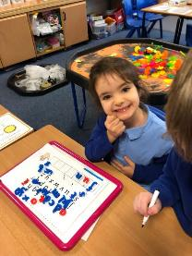
I enjoy exploring and choosing stories and other texts to watch, read or listen to, and can share my likes and dislikes.  LIT 0-01b / LIT 0-11b  Cosy reading time with my buddy. | 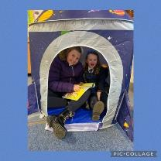
I can persuade, argue, explore issues or express an opinion using relevant supporting detail and/or evidence.  LIT 2-29a  Writing inspired by Martin Luther King. | 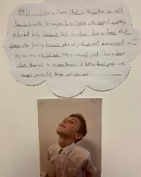

Literacy and Gàidhlig
I can convey information, describe events or processes, share my opinions or persuade my reader in different ways.  LIT 1-28a / LIT 1-29a  Creating posters to persuade others. | 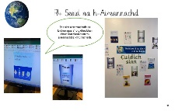
I can convey information, describe events, explain processes or combine ideas in different ways.  LIT 2-28a  Collating information from a range of source, and organising and presenting text and illustrations attractively. | 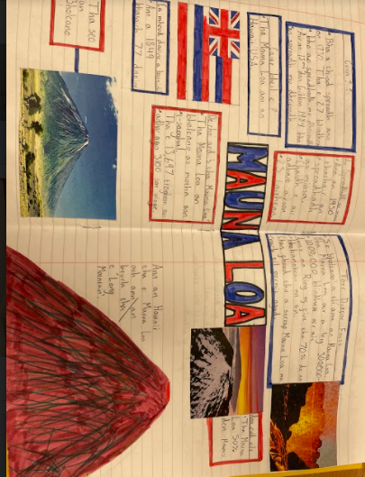
I explore sounds, letters and words, discovering how they work together, and I can use what I learn to help me as I read and write.  GAI 0-12a / LIT 0-13a /LIT 0-21a  Exploring Gaelic words and expanding vocabulary through play and songs. | 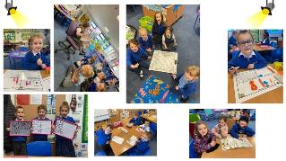

Numeracy and Mathematics
I am aware of how routines and events in my world link with times and seasons, and have explored ways to record and display these using clocks, calendars and other methods.  MNU 0-10a  Learning to tell the time and enjoying outdoor learning experiences. | 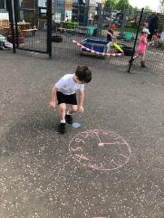
I have investigated how whole numbers are constructed, can understand the importance of zero within the system and can use my knowledge to explain the link between a digit, its place and its value.  MNU 1-02a  Using the interactive whiteboard to enhance learning of tens and units. | 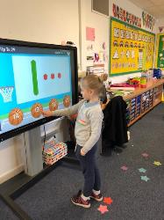

Health and Wellbeing
Through taking part in a variety of events and activities, I am learning to recognise my own skills and abilities as well as those of others.  HWB 1-19a  Children working together as team and having fun skipping outside. | 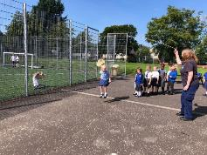
Representing my class, school and/or wider community encourages my self-worth and confidence and allows me to contribute to and participate in society.  HWB 0-12a / HWB 1-12a / HWB 2-12a / HWB 3-12a / HWB 4-12a  House captain elections. | 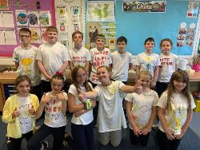
Together we enjoy handling, tasting, talking and learning about different foods, discovering ways in which eating and drinking may help us to grow and keep healthy.  HWB 0-30a  Learning about the Eat Well Plate. | 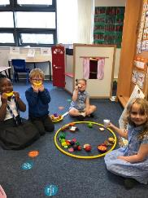

Science

I can help to design experiments to find out what plants need in order to grow and develop. I can observe and record my findings and from what I have learned I can grow healthy plants in school.  SCN 1-03a  Growing and planting and looking after plants. | 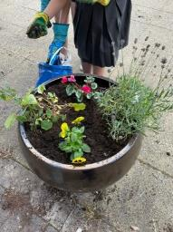
I have observed living things in the environment over time and am becoming aware of how they depend on each other.  SCN 0-01a  Making a wormery! | 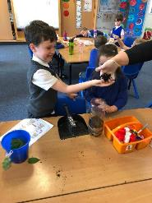

Technologies
I can investigate the use and development of renewable and sustainable energy to gain an awareness of their growing importance in Scotland and beyond.  TCH 02-02b  Learning about wind turbines and making one. | 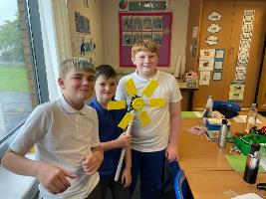

Expressive Arts
I have experienced the energy and excitement of presenting/performing for audiences and being part of an audience for other people’s presentations/performances.  EXA 0-01a / EXA 1-01a / EXA 2-01a  Children have many opportunities to present and perform throughout the school. | 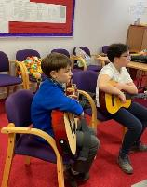

EXA 2-03a  Using chalks to create wonderful sunflowers. Observation of tone and texture. | 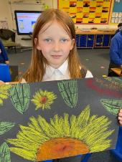
  I can create and present work that shows developing skill in using the visual elements and concepts.

Social Subjects
I can explain how the needs of a group in my local community are supported.  SOC 2-16a  Supporting Loaves and Fishes charity. | 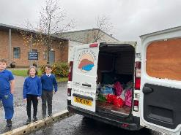

Religious and Moral Education
I am becoming aware of the importance of celebrations, festivals and customs in Christian people’s lives.  RME 0-03a  Welcoming a baby in different cultures. | 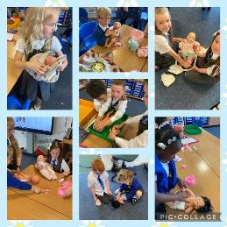

Early Years Provision
The school has two nursery classes (English & Gaelic) which provide stimulating learning environments for young children. Parents and carers from any area may apply to attend the nursery classes, however this does not mean children will automatically transfer to primary education in the school. Parents and carers wishing to apply for a place in either nursery, should complete an Early Years Application Form, available from the school. There is a separate Nursery Handbook with sector specific information available. All children who move from early years to primary education must register separately for school in the month of January.
We are very proud of our last Care Inspectorate Inspection report issued in September 2022.
You can read the report here: https://drive.google.com/file/d/1S6fpb_VdNYNOWgk_6lMZVIDre2GL03RU/view?usp=sharing
If you choose a Gaelic Medium Early Education for your child, we hope that you will continue your child’s educational journey by applying for a placement request (if living outside the school catchment) to Mount Cameron Primary School Gaelic Department and then a further placement request to Calderglen High School (our feeder secondary school) who also provide an excellent Gaelic Medium Education for young people.

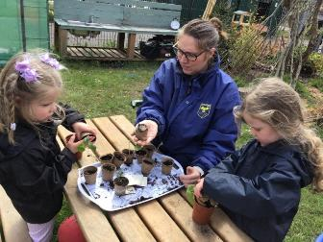

8. Assessment and tracking progress

We want to share with you on how your child’s learning is progressing. We do this through a range from the nursery settings through to the primary school setting.
- Teachers informally assess children’s progress daily. Every day teachers evaluate the impact of learning and teaching and amend their activities and planning to ensure that every child continues to make positive progress. Our teachers know their children very well.
- Teachers make professional judgements continually on how children are doing and provide differentiated teaching and learning. This ensures that your child is supported and challenged in their learning.
- Every day your child’s teacher will use a range of informal assessment strategies within teaching. We would refer to this as Assessment for Learning; teachers provide quality feedback to the children so that they know what they have done well and what they could do to further improve. Teachers ensure that children are clear in what they are learning and how they will be successful. This is called learning intentions and success criteria. As the children grow and develop, they will participate in setting their own more challenging success criteria as part of personal learning planning. Teachers use skilled questioning techniques to ensure that children understand their learning and can articulate what, how and why they have learned. Pupil involvement is key to assessment and all children will be involved in self-assessing their own work using clear criteria and engaging in peer assessment of others too. Children are taught to be critical friends, to peer assess and to listen and respond to feedback from others.
- More formal assessment activities include the use of standardised assessments in reading, spelling and numeracy across the school. We use the Scottish National Standardised Assessments (SNSA) and other assessments which the class teachers will put together to ascertain the development of skills and knowledge. It is very important to note that a standardised assessment is only a snapshot in time and is never used in isolation to the many other highly valuable approaches to assessing children’s progress.
- Teachers work with other teachers within and outwith the school ensuring they are familiar with the national standard. This is an aspect of moderation and sharing good practice. We regularly refer to a range of national resources to help us to form our professional judgements of learner progress.
- All teachers meet with the senior management team three times a year to discuss the progress of individual learners/groups and classes. This is a rigorous discussion around progress in reading, writing, listening and talking, numeracy and mathematics, pupil wellbeing, motivation and engagement. Next steps and actions are agreed together. This information is carefully tracked from class to class to ensure the continued progress of all learners.
- Assessment and tracking information is used to ensure that interventions to support learners are appropriately implemented, evaluated and have a positive impact on the child. Children’s learning is not linear and we aim to ensure that every child accesses additional support when they need it. If your child requires some additional support at some point in their learning journey, please do not worry as we will discuss this with you and ensure you are fully aware of any interventions or plans. We will also make sure that parents are aware of how they may also help their child at home.
- The Nursery Class use an electronic system called Learning Journals. High quality observations are uploaded for every child on a weekly basis so that parents can see how their child is progressing.

9. Reporting

There are many ways to report to parents on progress in learning. Our learner reports will help you to get to know more about the curriculum which each child follows and will describe their strengths, achievements and areas for development so you know what encouragement and support you can give. In consultation with the ‘Friends of Mount Cameron’ we have recently changed the time when the main school report on progress is issued. This will be in March/April instead of June. The rationale for this being it allows the parent and teacher to work on joint next steps which can then be re-visited at parents evening in June.
Reporting Diary
August/September – Meet the Teacher welcomes parents to visit their child’s class and discuss the overall approach to learning and teaching with their child’s teacher
November – Parent consultation meetings to discuss child’s progress
March/April - South Lanarkshire Council Pupil Progress Report
May/June – Parent consultation meetings to discuss child’s progress

There are many other opportunities for sharing and reporting on progress in learning throughout the school year:
- Class showcases of learning
- Class Assemblies
- Snapshot jotters
- Learning scrolls
- Google Classroom
- Parent workshops
- Communications – Weekly bulletin with weekly ‘What we have been learning’ and ‘Class Spotlight’ feature
- Use of learning journals in the Nursery.

Our ‘learner reports’ will help you to get to know more about the curriculum which each child follows and will describe their strengths, achievements, and areas for development so you know what encouragement and support you can give.
We welcome any comments or additional information from parents to help us provide the best possible education for your child.

10. Enrolment and Transitions
Enrolment – how to register your child for school.
To register your child for school you should complete our online registration form. This can be done using the South Lanarkshire website.
www.southlanarkshire.gov.uk/info/200186/primary_school_information/392/enrolling_your_child_for_school
If you have any difficulty in identifying your catchment school, please email Edsuppserv.helpline@southlanarkshire.gov.uk
The online registration form will ask you to provide each child’s full birth certificate and two pieces of recent official documentation both containing your permanent home address for example a utility bill, council tax statement, housing rent card, child benefit documentation.
Proof of where the child lives may also be needed.
If your child attends the nursery of your catchment school, please do not assume that they will automatically be transferred. You must register them as normal at the school that is in the catchment area for your home address
If parents want their child to go to another school, they must enrol in the first instance with their catchment school and intimate that they wish to make a placing request. An online placing request form is available from the SLC website – www.southlanarkshire.gov.uk or by contacting edsuppserv.helpline@southlanarkshire.gov.uk or phone 0303 123 1023.
Enrolment in the Gaelic P1 Class at Mount Cameron Primary School
Parents/carers wishing to enrol their child/children in Mount Cameron Primary Gaelic Medium Department need to enrol their child/children in their catchment school and then complete a placing request to be enrolled in Gaelic Medium Education at Mount Cameron Primary School Gaelic Department. A placing request form which is available online or from the catchment school. https://www.southlanarkshire.gov.uk/forms/form/80/primary_school_placing_request
Change of School/Placing Request
Normally children attend the school in their catchment area. However, there are times when parents may wish their children to go to other schools. If you wish your child to go to another school, then you may make what is known as a ‘placing request’. If you live in South Lanarkshire and decide to submit a ‘placing request’, we are unable to reserve a place in your catchment school until the Council have made a decision on the ‘placing request’. Please note if your ‘placing request’ application is unsuccessful and all places at your catchment school are filled you will be offered a place at the next nearest appropriate South Lanarkshire School.
Please note that if an application for a ‘placing request’ is successful then school transport is not provided.
If you move outwith your catchment primary school a ‘request to remain form’ must be completed. If you move outwith your catchment primary, this may affect your right to transfer to the associated Secondary School. Please note the secondary school is determined by the pupil’s permanent home address and chosen denomination. If you require further information, please contact Education Support Services on edsuppserv.helpline@southlanarkshire.gov.uk or 0303 123 1023.
Transition from primary to secondary school
Pupils normally transfer from primary to secondary school between the ages of 11½ and 12½, so that they will have the opportunity to complete at least 4 years of secondary education. Arrangements are made by the school to transfer children to the associated secondary school as determined by their home address. Parents of P7 children will be informed of the transfer arrangements made for their child to attend secondary school.
We will also provide you with information at this time on events designed to support P7 children before they move on to secondary school.
Communication in writing from the school will normally begin just before Christmas in preparation for secondary transition. Please look out for this information on Parent Portal.
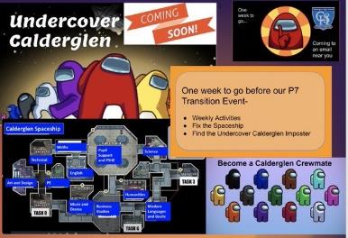
Primary to Secondary School Transition Activities
There are wide range of activities to support smooth transition to secondary school. For most children this will begin in Primary 7 however for children with additional support needs this process can start earlier and in response to your child’s needs.
Some of the secondary transition events include –
- Pupil day Visits to Calderglen High School
- Visits to Mount Cameron from Guidance Staff / Talks to pupils
- Visits to Mount Cameron by Pupil Support Staff to get to know the needs of our learners
- Virtual transition programme to help the children get to know their new learning environment
- Learning community transition sports event
- Transitional Learning projects
- Detailed communication between Primary 7 Teacher and Depute Head Teacher at Calderglen
- Transition review meetings with parents, Mount Cameron staff, Calderglen staff and any other relevant agencies
- Regular written communications from Calderglen High School
- Enhanced transition programme for any children who would benefit
Transition from primary school to secondary school for children in Gaelic classes
Mount Cameron Primary School is part of the Calderglen Learning Community and has a close working relationship with Calderglen High School. Calderglen High School in the only school in South Lanarkshire with Gaelic education provision. Gaelic speaking senior pupils from Calderglen High School regularly work alongside the children in Mount Cameron Primary Gaelic classes. Gaelic staff from Mount Cameron Primary and Calderglen High School work closely to support and continually develop transitions from primary to secondary education. The P7 Gaelic medium pupils will participate in all the transition events between Mount Cameron and Calderglen High School and participate in additional Gaelic specific activities.

